**Name: JOMOL R.K**

**Roll No:09**

**Batch:s2 mca b**

**Date:25/04/2022**

**NETWORKING & SYSTEM ADMINISTRATION LAB**

**Experiment No.: 1**

**Aim**

Familirization of linux commands

**Procedure**

1. sudo useradd username:

for adding user to tht admin privilages

syntax:

$ sudo useradd jo

password for mca :embedded

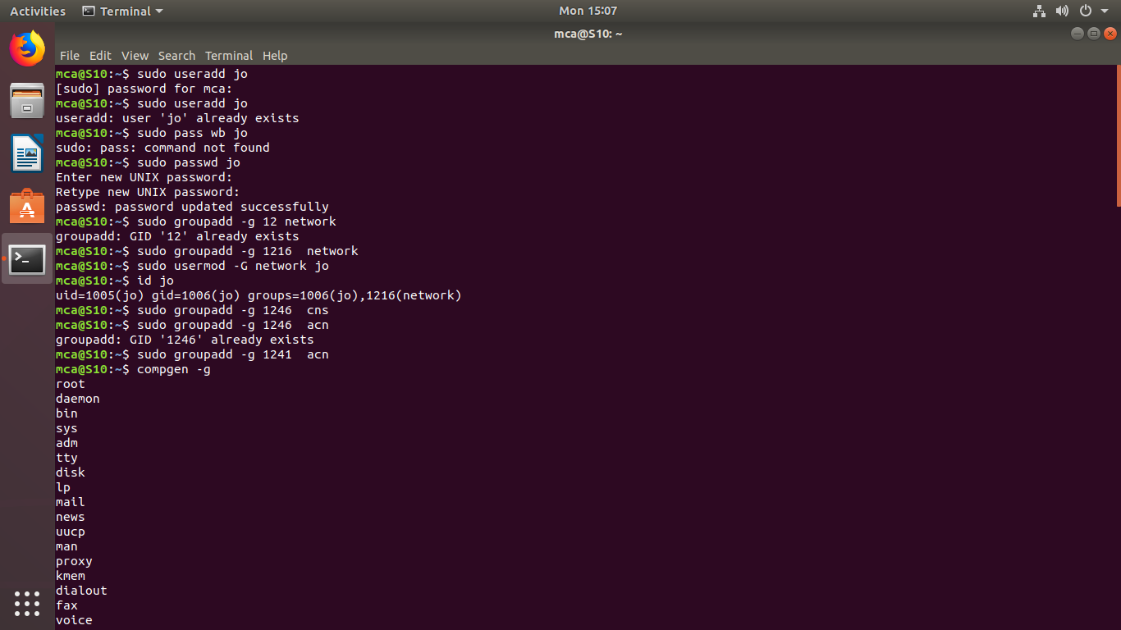

2. sudo passwd username:

for update the password for the user

syntax:

$ sudo passwd jo



3. sudo groupadd -g “idno” groupname:

for creating a group with a particular id

syntax:

$sudo groupadd -g 1216 network



4. sudo usermod -G “groupname” “username”

for adding the existing to the particular group

syntax:

$sudo usermod -G network jo



5. id username:

for display the information of the user

syntax:

id jo



6. compgen -g

compgen -g groupname

for display all the groups

syntax:

$compgen -g

$compgen -g network

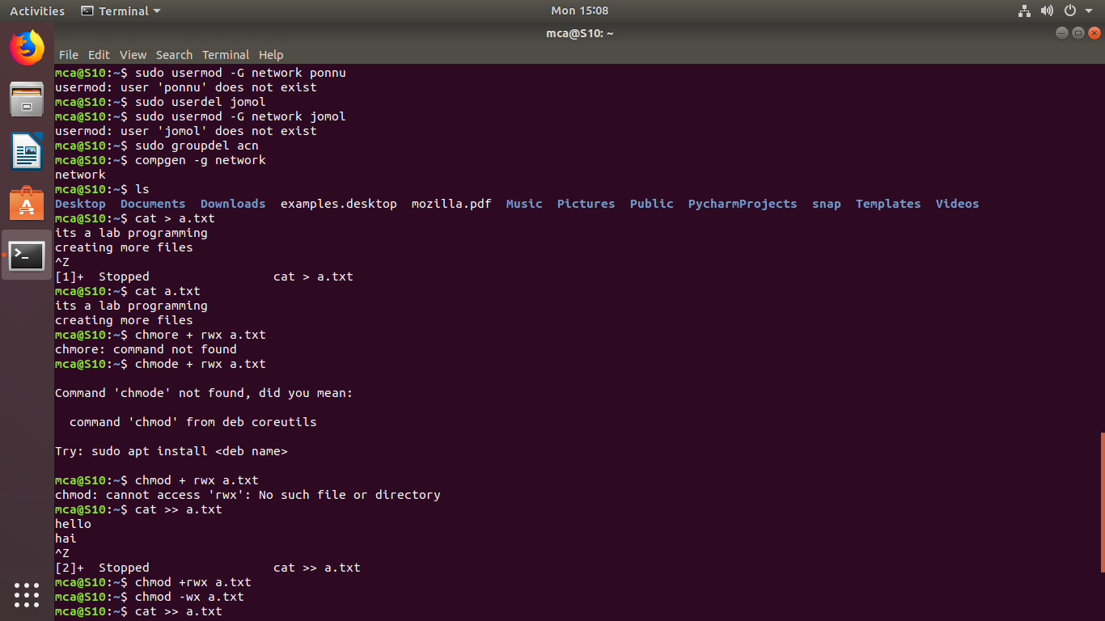

7. sudo userdel username:

for delete the user

syntax:

$sudo userdel jomol



8. sudo groupdel groupname

for delete a particular group

syntax:

$sudo groupdel acn



9. chmod +rwx filename

for changing the directory and add con tent to existing file with +

the permission is permitted

syntax:

$chmod +rwx a.txt

chmod -wx a.txt

permission is denied

syntax:

$chmod -wx a.txt



10. sudo chown username filename:

for giving permission to the user in a particular filename

syntax :

$sudo chown jomol a.txt

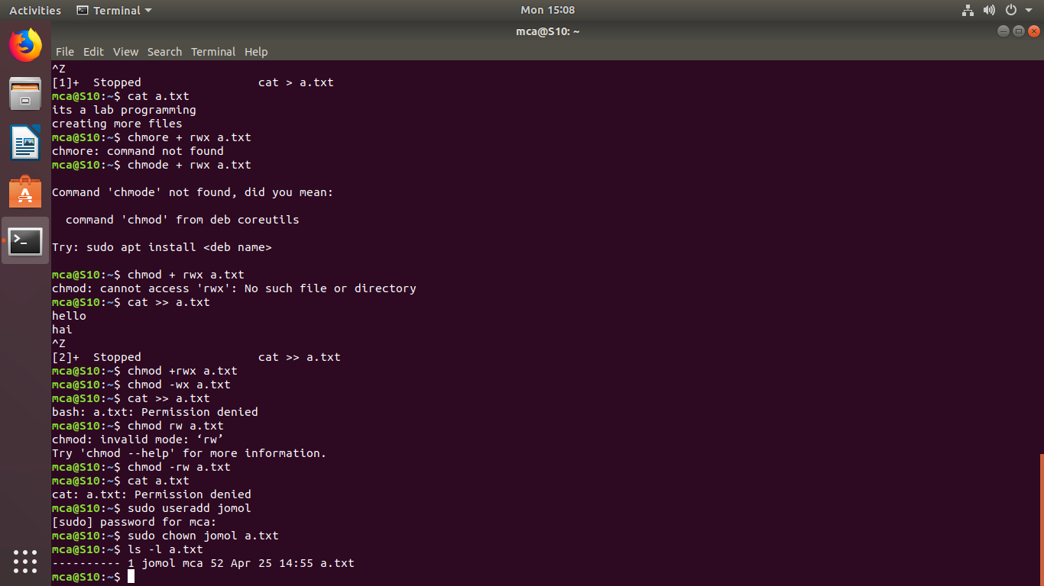

11.ifconfig -a

for getting ip address

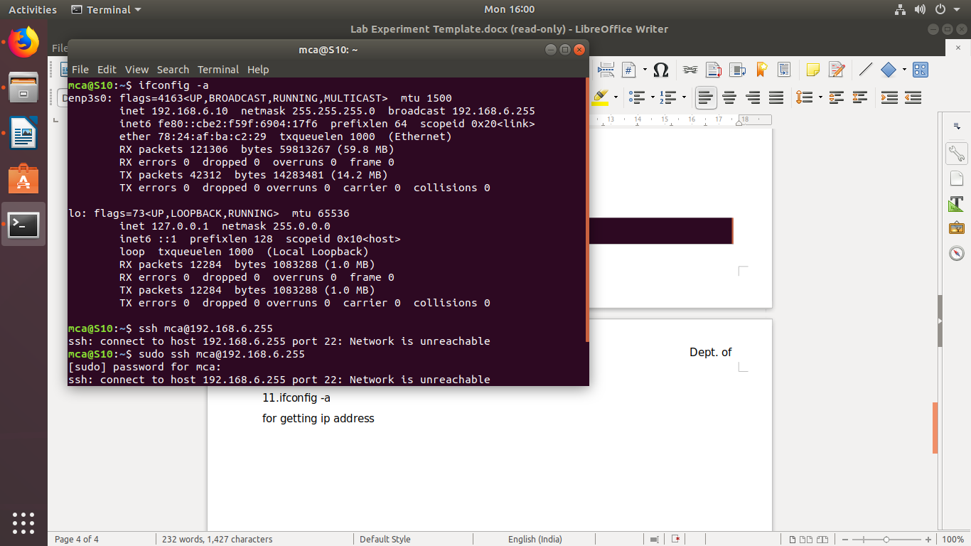

12.ssh [mca@192.168.6.255](mailto:mca@192.168.6.255)

for access the other user

